**Using InfluxDB**

1. Bucket is where you store data. Choose the ‘data’ tab and create or choose a bucket where you want your data to be inserted.

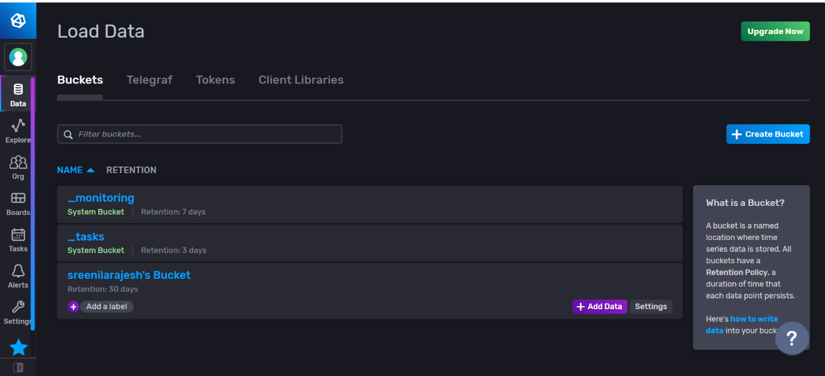

2)  Secure interaction between users and data is done through the use of **authentication tokens**. A token belongs to an organization and identifies InfluxDB permissions within the organization. Choose/Create the token you need.

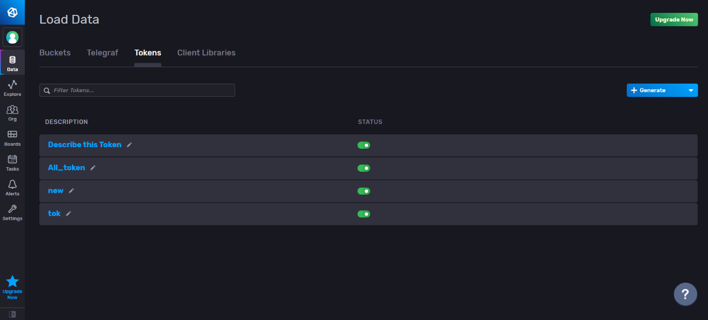

1. As we are going to use python for inserting data into influxdb, choose python from client libraries.

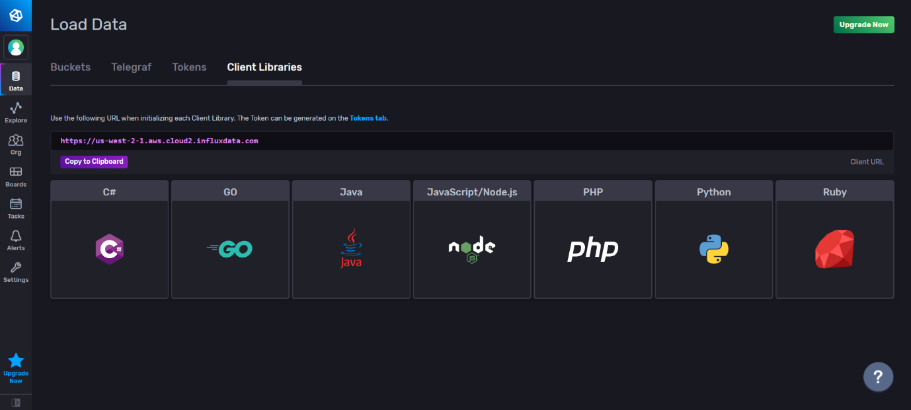

1. Create an InfluxDB client using the influxdb-client package and the mentioned URL , in Python.

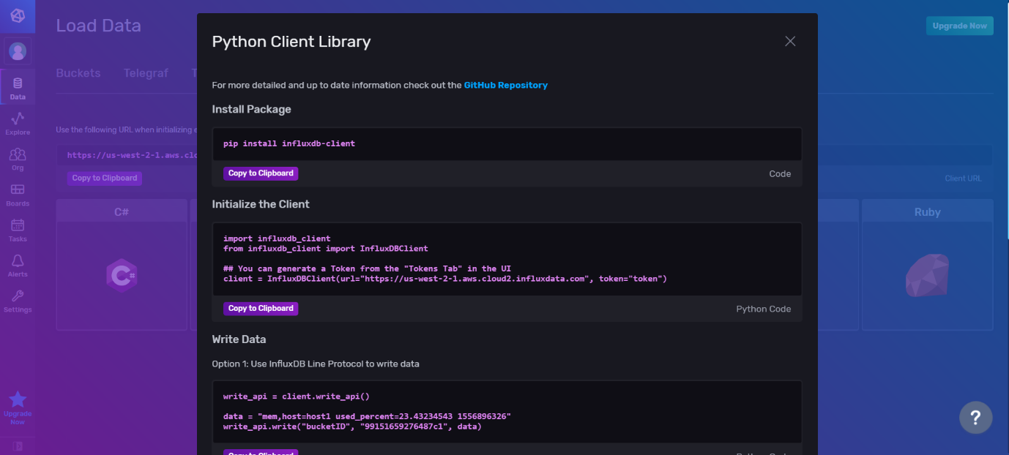

5)There are 3 ways to write data into InfluxDB. We have written data using Points. Point is like a record. While creating a point, you need to mention the measurement (similar to table) it belongs to. Also mention the values to be indexed in tags, and other values in fields. The point is inserted indexed with current time if time is not mentioned.

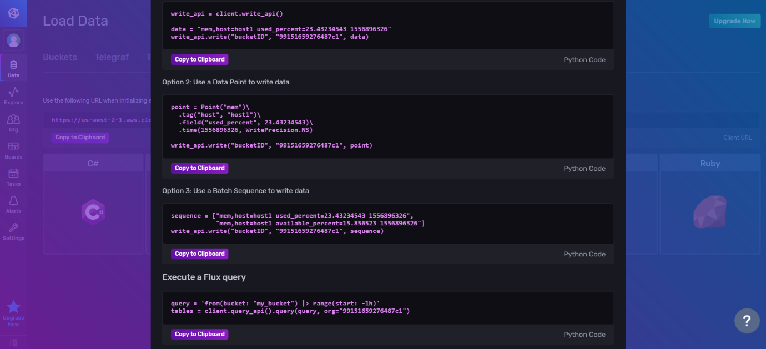

1. Once the data is inserted into the bucket, you can visualize it in the Explore tab.

